We are a part of Greenheart Learning Partnership- Where we BE, we BECOME, we BELONG.
The Orchards Primary Academy - Where learning has no limits.
Reaside Primary Academy – Where ambition and achievement align.
_________________________________________________________________
Our Behaviour Guidance
This policy should be read in conjunction with the:
- Anti-Bullying Policy
- Safeguarding and Child Protection Policy
- Equality Policy
- Online Safety Policy
Aims of the Policy
- To create a culture of consistently good behaviour: for learning, for community, for life.
- To ensure that all learners are treated fairly and shown respect in order to promote good relationships and achieve their potential
- To praise and reward good behaviour
- To help learners take control over their behaviour and be responsible for the consequences of it
- To develop self-aware learners who take control of their behaviour and who are responsible for the consequences of it.
- To build a community which values kindness, care, good humour, good temper and empathy for others
- To ensure consistency of response for both positive and negative behaviour
- To ensure that excellent behaviour is a minimum expectation for all
- To develop positive relationships with both pupils and parents to therefore enable early intervention if required
Purpose of this policy
To provide simple, practical procedures for staff and learners at The Orchards Primary Academy and Reaside Academy, that:
- Recognise behavioural norms
- Positively reinforce behavioural norms
- Promote self-esteem and self-discipline
- Teach appropriate behaviour through positive interventions
At The Orchards and Reaside, we are committed to providing a safe and nurturing environment that fosters positive behaviour, respect and a conducive atmosphere for learning. This behaviour guidance outlines our expectations and procedures regarding the behaviour of our young people.
Our school “Values of the Month” are fundamental to our behaviour guidance, but each school has two other sets of values that are unique to their schools:
The Orchards Primary Academy: Reaside Primary Academy:
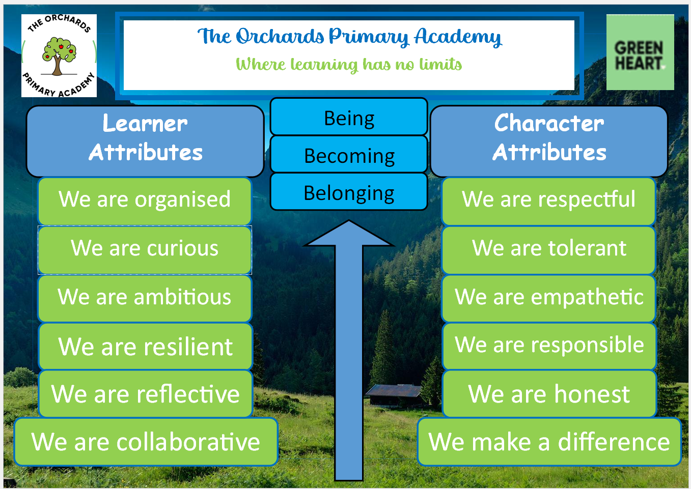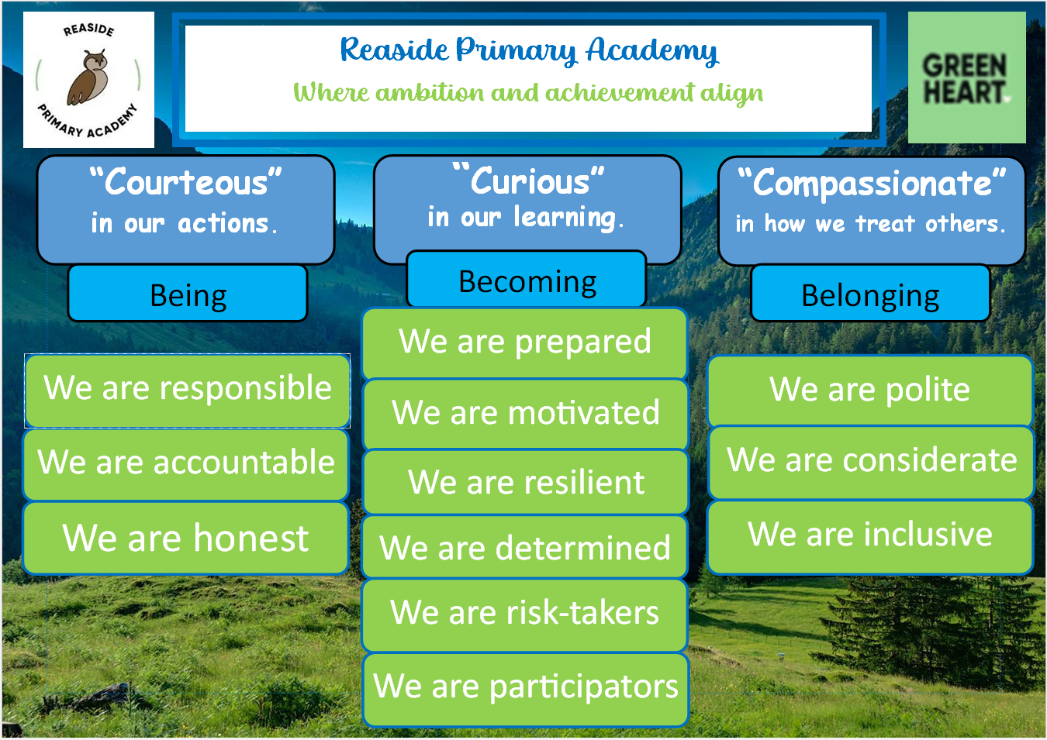
Monthly Values:
 |  |  | 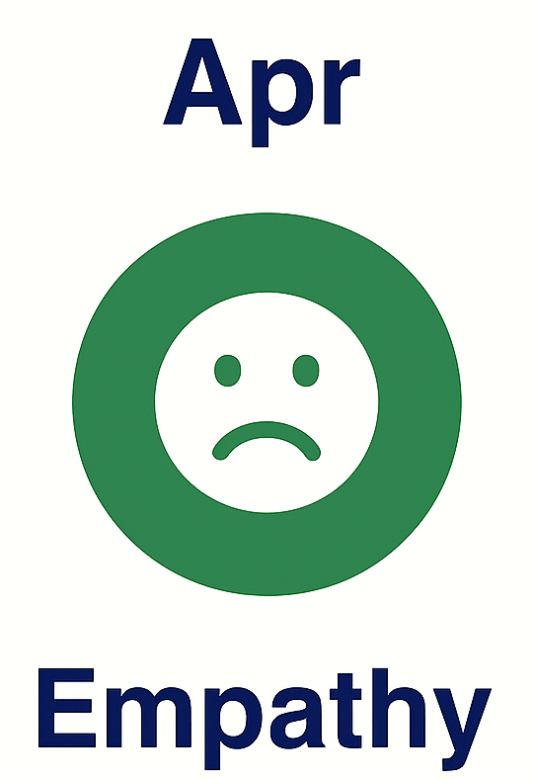 | 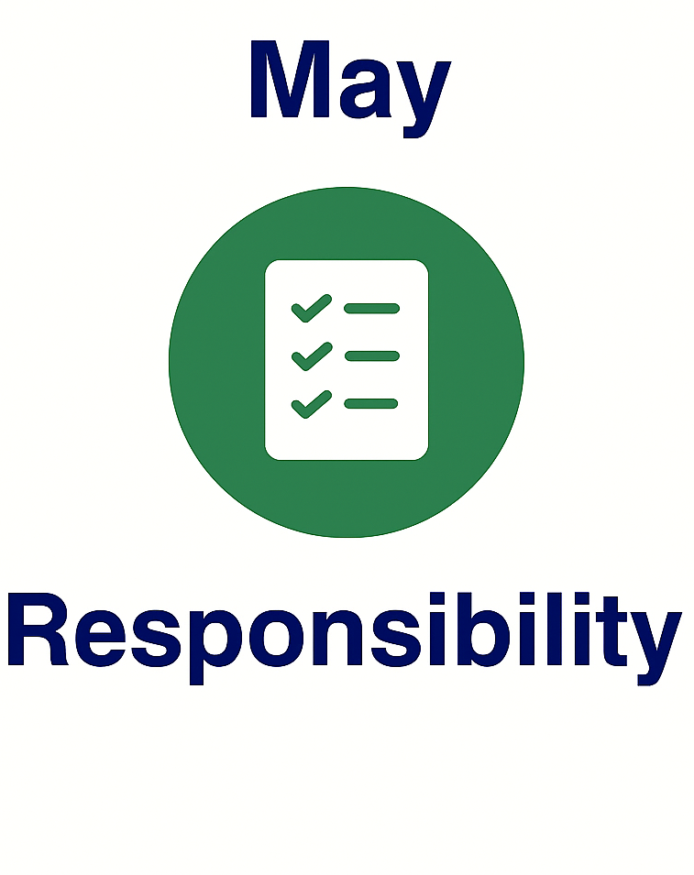 | 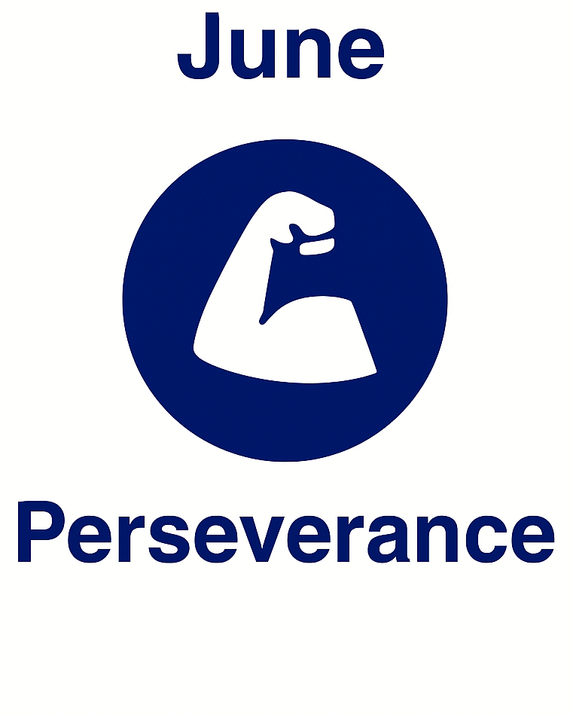 | 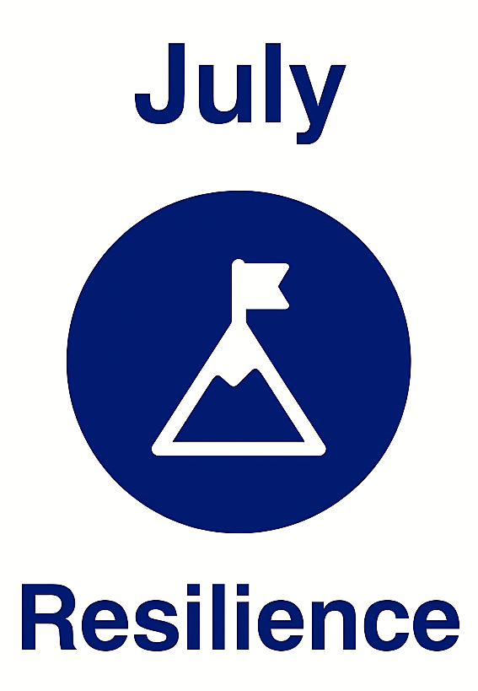

Rewards and praise
At The Orchards and Reaside, we use rewards and praise to promote positive behaviour and attitudes:
- All staff and young people belong to a house team (Air, Earth, Water and Fire). Both staff and young people are encouraged to give team points to reward positive and kind acts of behaviour.
- Celebration assemblies award several awards for each class. These awards link to the school values to reward and reinforce positive behaviour or standards- Attributes awards, Perfect Presentation awards, Marvellous Manners awards, Rainbow awards for the above and beyond.
- Stickers
- Pen licenses
- Verbal praise
- Visit to Executive Head Teacher/Principal or Phase Leader for good work, or behaviour
- Inviting parents in to share good work
- Phone calls home for positive behaviour
- Public recognition in our weekly whole school or phase assemblies
- Sending a post card home in recognition of good work/conduct
Managing undesired behaviour
We actively strive for excellent standards of behaviour and most young people, most of the time, make correct and positive behaviour choices. However, at times, our young people must be guided in how to make better behaviour choices and to take personal responsibility when unacceptable behaviours occur. We recognise it is necessary and realistic for sanctions to be applied when unwanted behaviour occurs. We clearly communicate our standards and expectations of behaviour to ensure consistency of sanctions through each year group as our young people move throughout the academy. All sanctions are based on a case-by-case basis but the behaviour strategy will always be followed.
Contact with Parents
It is the responsibility of the class teacher to feedback to parents about both the positive and negative behaviour of children in their class. Sometimes the phase leader will make those calls if needed.
Meeting with Parents
A parent will be asked to attend a formal behaviour meeting with the class teacher and an appropriate member of SLT if the child’s behaviour is deemed to not be improving, or several restorative meetings have taken place with no visible improvement seen. If behaviour continues to be a cause for concern, the principal or executive headteacher will meet with parents to discuss next steps.

The Orchards and Reaside Behaviour Strategy:
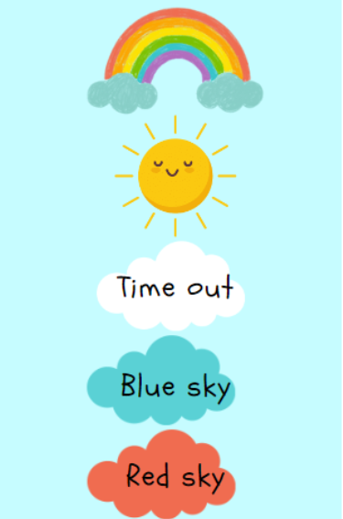
- Every day, and every lesson, is a new start. All children start the day on the class sunshine. This shows that they are following our values and rules in the classroom and around the academies.
- If a child displays unwanted behaviour, they will receive a verbal warning and asked to reflect on how to promote positive behaviour.
- Further repeated incidents of unwanted behaviour will result in ‘time out’ in a partner classroom; this is a time for reflection- this is called ‘White Cloud’. Before the young person returns to their own classroom, a coaching conversation will take place so that the young person understands the impact of their unwanted behaviour and how to promote positive behaviour once they return to their classroom.
- If further unwanted behaviour occurs, the young person’s name will move to a ‘blue sky’ card. If a young person’s name is moved to blue sky, they will spend half a day working separately to their peers, overseen by a member of the senior leadership team. During this time, the child will be provided with further opportunities for reflection and exploration of feelings and emotions to enable them to understand their behaviour. Break/lunchtime will be missed depending on which free time is closer.
- For serious incidents of unwanted behaviour such as physical violence towards peers, racism, vandalism etc., young people will move to a ‘red sky’ card. If a young person’s name is moved to red sky, they will spend 1-2 days in ‘red sky zone’, overseen by a member of the senior leadership team. During this time, the young person will be provided with further opportunities for reflection and exploration of feelings and emotions to enable them to understand their behaviour. Parents will be invited to discuss their young person’s behaviour if they reach the red sky so that we are able to work in conjunction to promote the expected behaviour requirements that keep everyone at both schools happy and safe.
- All unwanted behaviour is logged on our academy system ‘Bromcom’. Each log will indicate the type of incident and sanction received. Negative behaviour points will be carefully monitored to ensure that poor behaviour doesn’t continue.
- Violence, aggression towards staff or answering back is zero tolerant in our schools.
- A child can move their name up the chart, to the class rainbow, if and when they demonstrate exceptional positive behaviour or conduct. This is considered as going “above and beyond”.
- If a young person ends the day with their name on the class rainbow, their name will be written in the rainbow book, thus keeping a record of their positive behaviour.
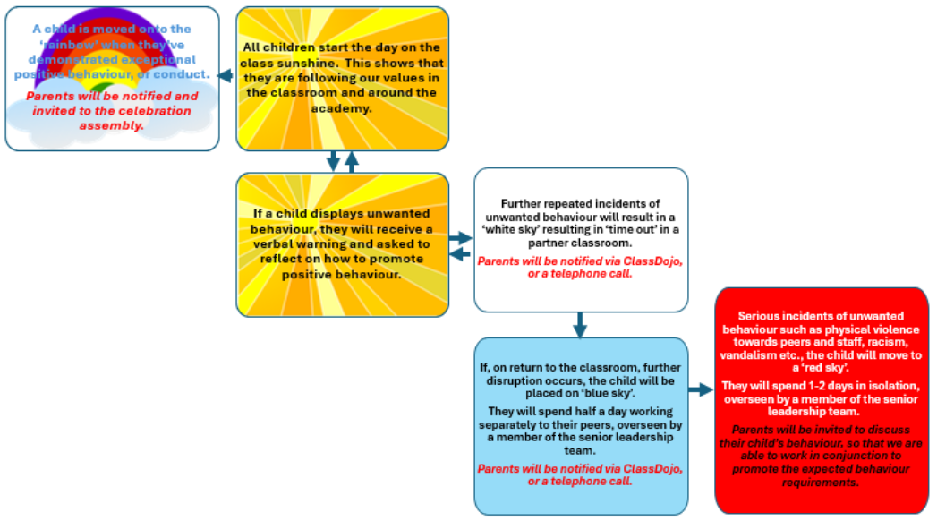
- Our system is fluid; young people can move throughout the day, depending on the behaviour that they display.

Individual Behaviour Plans
On the occasions when a young person repeatedly makes inappropriate behaviour choices, and needs more support in choosing the correct behaviour, we create an individual behaviour plan (IBP) to modify and encourage positive behaviour. Individual behaviour plans are developed in collaboration with teachers, young people and parents to support and improve behaviour of individual young people. Personalised behaviour targets and report cards are discussed and set with the teacher, parent and young person and monitored daily.
The report cards will take the form of ‘yellow’, or ‘red’ dependent on the level of behaviour. Each individual report card will contain bespoke targets relevant to the young person and a point system to encourage positive behaviour. The report card will be viewed at the end of each lesson/break/lunch by the Executive Headteacher, or Principal.
If a young person has received a score of 3, or lower, then they will remain indoors during break/lunch (under the supervision of a member of the senior leadership team) to reflect on their behaviour and to improve their score for the remainder of the day. At the end of each school day, the report card must be signed by the Headteacher, or Deputy Headteacher.
- YELLOW: Children on a yellow card are those who present constant low-level behaviours/ disruption.
- RED: Children on a red card are those that have received multiple ‘red sky’ consequences, or have previously been suspended due to their actions.
Children will remain on a report card for a period of 4 to 6 weeks, as outlined in their Individual Behaviour Plan (IBP). After this time, their progress will be reviewed.
- If the young person meets their behaviour targets, they will no longer need a report card, and their IBP will be considered complete.
- If the young person started on a red report card, they will move to a yellow report card once initial improvements are seen. They will then stay on the yellow report card for a further 4 to 6 weeks before a further review takes place.
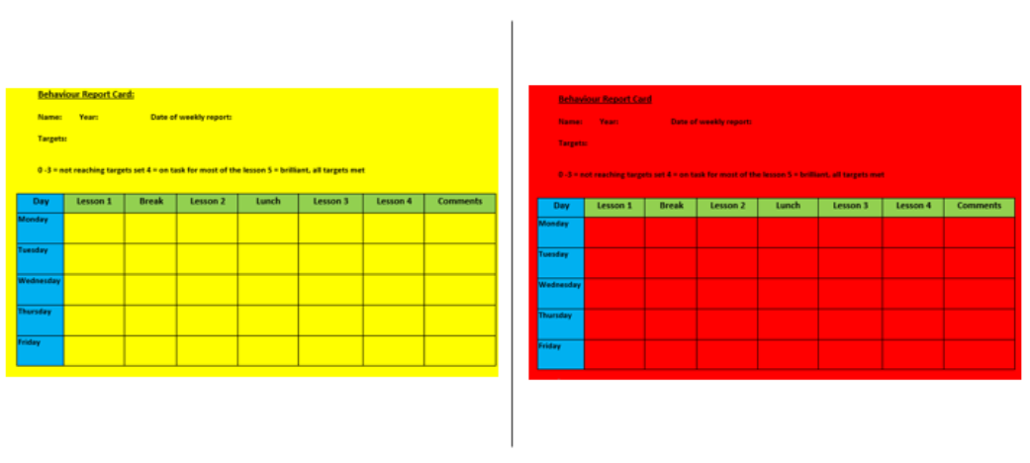At that point, a decision will be made to either remove the report card, or continue monitoring until there is a significant improvement in behaviour. If a pupil is on a red card and they complete their 6 weeks successfully, the executive headteacher only will choose if the report is downgraded. Equally, if a pupil is on a yellow report, the executive headteacher will make the decision once again if a child comes off their report all together.
At The Orchards and Reaside, we aim to nurture young peoples’ positive behaviour choices through developing self-awareness and a sense of personal responsibility for their actions. Young people are given daily opportunities to evaluate and reflect on their behaviour, both positive and unwanted, with staff members. Weekly review and assessment meetings involving the young person, teacher and parent ensures appropriate and relevant targets and strategies to help support and improve the child's behaviour.
Suspension/Exclusion
Some behaviours may result in fixed term suspensions being imposed by the school. All suspensions will follow DfE guidance. Alternatively, the Executive Headteacher or the Principal may consider a period of internal suspension as a suitable consequence for continued poor behaviour or an alternative suitable consequence- this is the schools’ ‘blue’ and ‘red’ sky. Suspensions will be decided by the Executive Headteacher or Principal and will only be considered where there is clear evidence that the sanction system has been used appropriately. There may be circumstances where an immediate an external suspension may be required- this are decided by the executive headteacher only. They include:
- Fighting
- All forms of bullying
- Racist, sexist or homophobic comments
- Using abusive /offensive language
- Possession of a weapon
- Assaulting a member of staff
- Extreme behaviour that may jeopardise the safety of the pupil or others in school
- Consistent disruptive behaviour that is impacting on the learning of others
A permanent exclusion may be issued by the Executive Headteacher. The decision to exclude a pupil permanently will only be taken in response to a serious breach or persistent breaches of the school's behaviour policy or where allowing the pupil to remain in school would seriously harm the education or welfare of the pupil or others such as staff or pupils in the school.
This is not a decision that this school takes lightly and is an absolute last resort.
Monitoring and reviewing behaviour
At The Orchards and Reaside, we recognise the importance of monitoring the effectiveness and impact of our behaviour systems as we strive to continuously improve behaviour and ensure all young people have positive attitudes to learning. Bromcom logs and Rainbow books are reviewed as part of the leadership monitoring cycle. Children who persistently display unwanted behaviour are identified and support is given to the young person and class teacher. It may be at this point that external agencies may be involved to support the young person / family; pastoral support, school nurse, early help worker or family support worker so that behaviour is managed effectively.

Effective from: January 2026
Review date: January 2027

